Lesson 12: Inference for Two Means; Paired Data
Homework

Solutions

Problem | Part | Solution
1 | - | The difference between these tests is that when using paired data we are testing the mean of the difference of the paired data, not the individual datasets.
2 | - | This is an example of paired data because knowing the subject of the first experiment (the flint and steel) determines the subject of the second experiment (the battery and steel wool).
3 | - | There are two possible correct solutions, depending on the order of subtraction: (-138.171,146.504) or (-146.504,138.171). We are 95% confident that the true mean difference in time is between -138.171 and 146.504 (or, if you subtracted the opposite way, -146.504 and 138.171).
4 | - | There is inconclusive evidence that there is a difference between these methods since zero is contained in the confidence interval.
5 | - | (-2.692,0.025) We are 95% confident that the true mean difference of the before and after stress levels is between -2.692 and 0.025.
6 | - | Yes. Since the confidence interval contains 0, it is plausible that the true mean difference is 0, meaning that the class could have no effect on stress levels. There is inconclusive evidence that there is a difference.
7 | - | $H_{o}:μ_{d}=0$  $H_{a}:μ_{d}≠0$
8 | - | 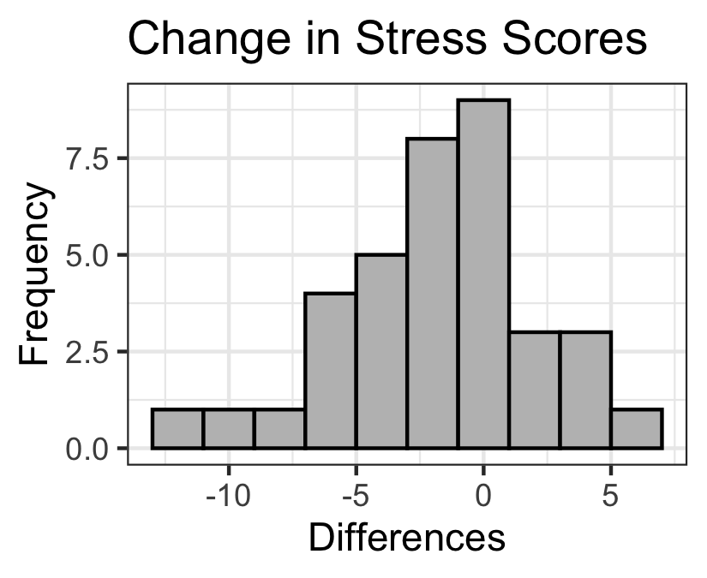  Note: This histogram should be of the differences, not the individual data sets.
9 | - | a. We assume that the data were collected using a simple random sample (SRS)  b. We have a large sample (n = 36), so we can conclude that the distribution of sample mean is normal.
10 | - | -$\overset{‾}{d}=−1.333$  - $s_{d}=4.014$  - $n=36$
11 | - | $t=−1.993$ $df=35$
12 | - | 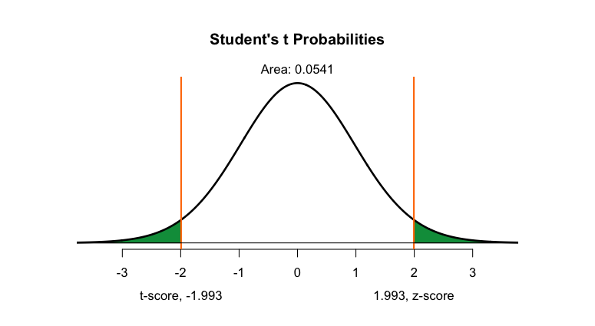
13 | - | $p=0.054$
14 | - | $p=0.054>0.05=α$, fail to reject the null hypothesis.
15 | - | There is insufficient evidence to suggest that the mean Zung SAS scores changed as a result of this course
16 | - | The conclusions are the same when we do a 95% confidence interval and a two-sided hypothesis test with a level of significance = 0.05.
17 | - | $$H_{o}:μ_{d}=0$$  $$H_{a}:μ_{d}<0$$
18 | - | 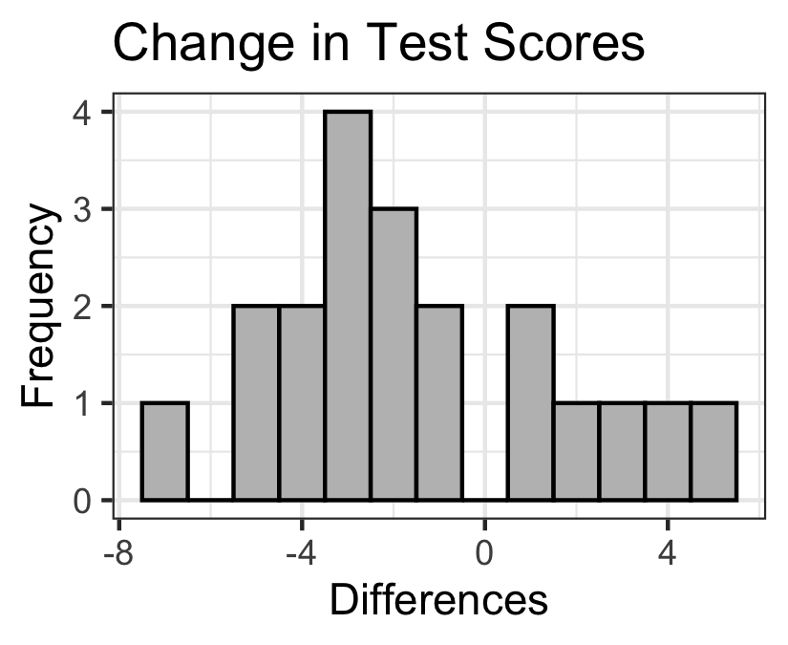  Note: This histogram should be of the differences, not the individual data sets.
19 | - | a. We are told that the data were collected using a simple random sample (SRS)  b. We have a small sample (n = 20), so we need to create a histogram to be sure the distribution of differences is normal in order to be able to claim that the distribution sample means is normal:  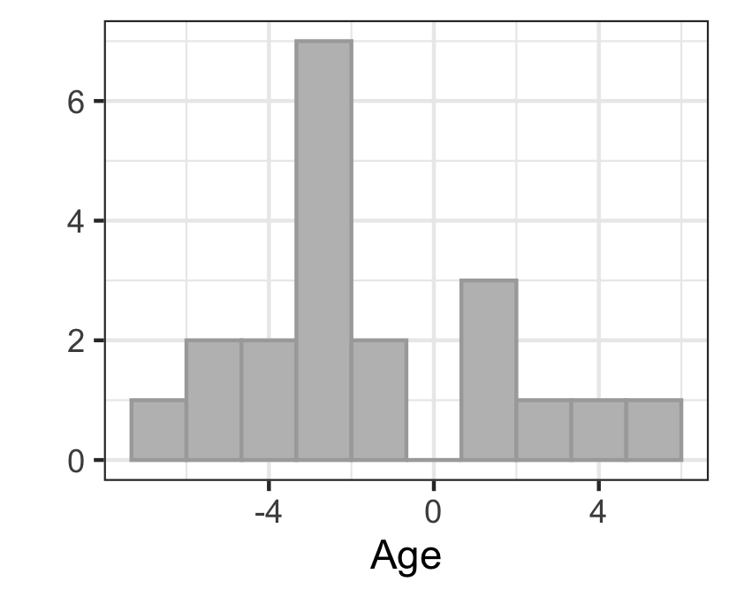  The differences appear to be normal
20 | - | -$\overset{‾}{d}=−1.45$  - $s_{d}=3.203$  - $n=20$
21 | - | $t=−2.024$ $df=19$
22 | - | $p=0.029$
23 | - | $p=0.029<0.05=α$, reject the null hypothesis.
24 | - | There is sufficient evidence to suggest that there is a decrease in retention immediately following language learning instruction and one week after language learning instruction.

